**RESTful Web Service End Points :** 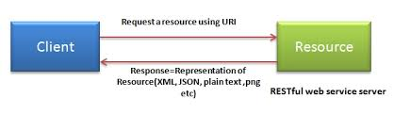

### **smartcms (java) URL : http://localhost:8080/smartcms/**

|  |  |  |  |
| --- | --- | --- | --- |
| **#** | **URI** | **Method** | **Description** |
| **1** | **/website/list** | **GET** | **Returns a list of all the websites** |
| **2** | **/website/{id}** | **GET** | **Return the website based on the id** |
| **3** | **/website/{id}** | **PUT** | **Update content based on id** |
| **4** | **/website/{id}** | **DELETE** | **Delete the issuer in the data store based** |
| **5** | **/website/add** | **POST** | **Inserts the website into the data store based on the contents of the json** |
| **6** | **/download/{id}** | **GET** | **http://localhost:8080/smartcms/download/{id}** |
| **7** | **/upload/{id}** | **POST** | **http://localhost:8080/smartcms/upload/{id}** |

**smartcms (php)**

**URL : http://localhost:8082/SmartCMS/**

|  |  |  |  |
| --- | --- | --- | --- |
| **#** | **URI** | **Method** | **Description** |
| **1** |  |  |  |
|  |  |  |  |